**Sony Payment SFRA**

Version <21.1.0>



Table of Contents

1. Summary 2

2. Component Overview 3

2.1. Functional Overview 3

2.2. Use Cases 3

2.3. Limitations, Constraints 4

2.4. Privacy, Payment 4

2.5. Compatility 4

3. Implementation Guide 5

3.1. Setup 5

3.2. Request an account control interface for merchant 5

3.3. Configuration 5

3.3.1. Assignment of Cartridges 5

3.3.2. Import metadata 7

3.3.3. Import production service 7

3.3.4. Custom Preferences 9

3.3.5. Configuration Enforce HTTPS 11

3.3.6. Configuration custom log 12

3.4. Custom Code 13

3.5. External Interfaces 14

3.6. Firewall Requirements 14

3.7. Failover 14

3.8. Testing 14

4. Operations, Maintenance 15

4.1. Data Storage 15

4.2. Availability 15

4.3. Support 15

5. User Guide 16

5.1. Roles, Responsibilities 16

5.2. Business Manager 16

5.2.1. Sony Order Management in BM 16

5.3. Storefront Functionality 18

5.4. Sony Merchant Dashboard user guide 18

6. Known Issues 18

7. Release History 18

# Summary

* Integrate B2C Commerce SFRA with SonyPayment.
* Deployment of an integration cartridge and modification of Storefront code.
* SonyPayment intergrated with Storefront Reference Architecture base 5.1.0
* This cartridge can work with locale Japanese (Japan)

# Component Overview

## Functional Overview

***Token usage:***

It is a service to prevent end-user’s credit card information from passing through your system environment at all by using the token payment API provided by Sony Payment Services Inc. By using token payment API, the card information entered by end-user is transmitted directly to our server, and in exchange we respond with the token code instead. The authorization processing becomes possible without handling the card information by setting the token to the existing authorization request.

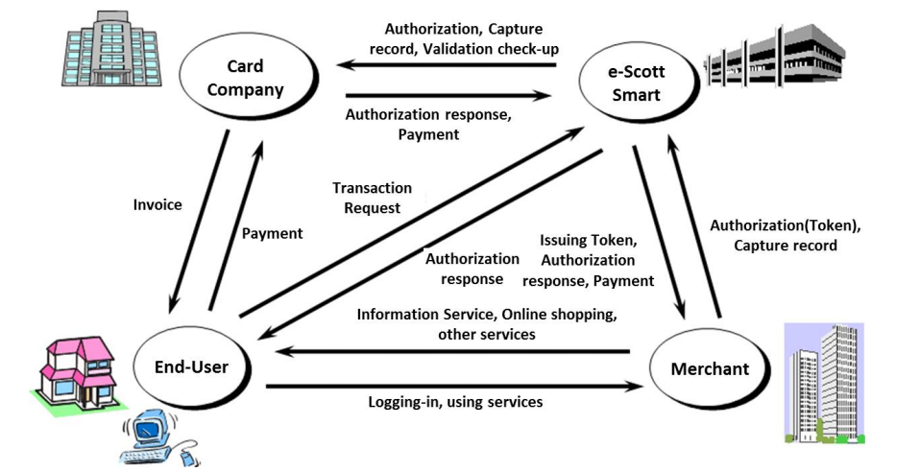

***3D Secure service:***

3D Secure Service is a highly recommended service by the card industry used upon Credit Card Payment. The service aims to prevent fraud usage of crdit cards by users entering ID and password issued by card companies exclusively for internet usage. Users input the information to the card companies’ verification page.

e-SCOTT Smart will receive information necessary for 3D Secure Verification Service through redirection of end-user’s input and display card companies’ verification page. By end-user inputting internet exclusive ID/Password to card company password verification page, the card company will directly verify those data and only verification result will be notified to the end-user. In addition, function that merges 3D Verification and Authorization processing in one request and return 3D Verification result and authorization result together is available.

Functional Overview is to build a cartridge for Sony payment method that will be based on the default checkout process of B2C Commerce.

The following specific features are developed:

* Merchant info configures in BM
* Integration Payment option in Payment method
* Error handling
* Credit card process
  + Authorize / Cancellation of authorization
  + Capture

Credit card management (save for future purchase and view from user account page).

## Use Cases

Please see file for use case scenarios:

link_sonypayment\documentation\TestCases\SonyPayment_SFRA_20201216.xlxs

## Limitations, Constraints

To enable 3D Scure, The Redirect URL parameter limited 64 characters. To able working on sandbox with long domain, please upload these files on server supported https. On Production, the domain will be less than 64 characters, so no need to use these files below.



After edit and upload files in zip above. Go to configure redirect and post URL in site preference:

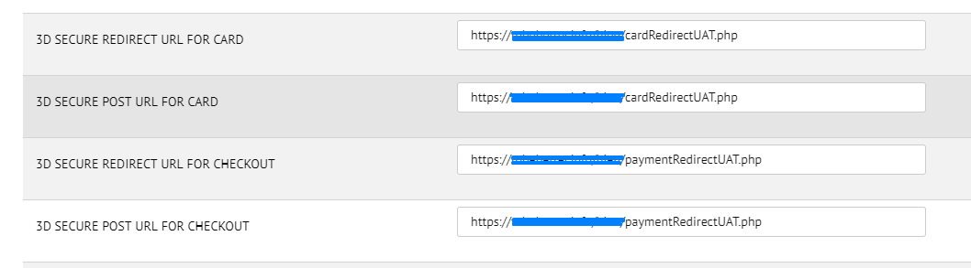

There are not any export/import functions of B2C Commerce to complete the payment status.

## Privacy, Payment

The customer data is not sending via URL, it sends the customer ID only for account registration in Sony Payment site. For the credit card number, it will be registered for sending to Sony Payment process.

## Compatility

|  |  |  |
| --- | --- | --- |
| Browsers | OK / NOK | Comment |
| Internet Explorer 9 and above (Windows OS) | OK |  |
| Chrome (Windows OS) | OK |  |
| Firefox (Windows OS) | OK |  |
| Ipad mini(Safari) | OK |  |
| Samsung (Chrome) | OK |  |

# Implementation Guide

## Setup

* int_sonypayment_sfra, bm_sonypaymentorders_sfra
* Sony Payment Authorize API Url : <https://www.e-scott.jp/online/aut/OAUT002.do?OperateId=1Auth>
* Sony Payment Cancel API Url : <https://www.e-scott.jp/online/aut/OAUT002.do?OperateId=1Delete>
* Sony Payment Authorize & Capture API Url : <https://www.e-scott.jp/online/aut/OAUT002.do?OperateId=1Gathering>
* Sony Payment Capture API Url : <https://www.test.e-scott.jp/online/aut/OAUT002.do?OperateId=1Capture>
* Sony Payment New Member API Url : <https://www.e-scott.jp/online/crp/OCRP005.do?OperateId=4MemAdd>
* Sony Payment Edit Member API Url : <https://www.e-scott.jp/online/crp/OCRP005.do?OperateId=4MemChg>
* Sony Payment Invalid Member API Url : <https://www.e-scott.jp/online/crp/OCRP005.do?OperateId=4MemInval>
* Sony Payment Cancel Invalid Member API Url : <https://www.e-scott.jp/online/crp/OCRP005.do?OperateId=4MemUnInval>
* Sony Payment Delete Member API Url : <https://www.e-scott.jp/online/crp/OCRP005.do?OperateId=4MemDel>
* Sony Payment View Member API Url : <https://www.e-scott.jp/online/crp/OCRP005.do?OperateId=4MemRef>
* 3D Secure API Url : <https://www.test.e-scott.jp/online/tds/OTDS010.do>
* Token Service URL : <https://www.e-scott.jp/euser/stn/CdGetJavaScript.do?k_TokenNinsyoCode>=

## Request an account control interface for merchant

Send a request to Sony Payment service to receive an account information: <http://www.sonypaymentservices.jp/>

You will receive a control interface for merchant

Testing: https://www.test.e-scott.jp/merchant/?jigysyaCode=*********1

Production: https://www.e-scott.jp/merchant/?jigysyaCode=*********1

Account information will be used for step 3.3.3 Custom Preferences

## Configuration

### Assignment of Cartridges

Sony Payment SFRA support SFRA version. Set cartridge path on your site.

* Use Cartridge: int_sonypayment_sfra:app_storefront_base

Go to BM -> [Administration](https://bluecom02-alliance-prtnr-hk01-dw.demandware.net/on/demandware.store/Sites-Site/default/ViewApplication-ExpandMenuGroup?MenuGroupID=AdministrationMenu&OverviewPage=SiteNavigationBar-ShowAdministrationOverview) ->  [Sites](https://bluecom02-alliance-prtnr-hk01-dw.demandware.net/on/demandware.store/Sites-Site/default/SiteNavigationBar-ShowMenuitemOverview?CurrentMenuItemId=sites) ->  [Manage Sites](https://bluecom02-alliance-prtnr-hk01-dw.demandware.net/on/demandware.store/Sites-Site/default/ViewChannelList-ListAll?CurrentMenuItemId=sites) -> Your Site – Settings Setting cartridge as below

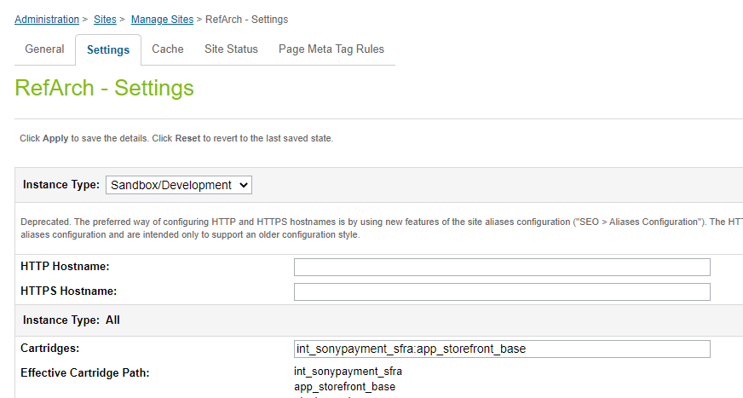

Go to BM -> [Administration](https://bluecom02-alliance-prtnr-hk01-dw.demandware.net/on/demandware.store/Sites-Site/default/ViewApplication-ExpandMenuGroup?MenuGroupID=AdministrationMenu&OverviewPage=SiteNavigationBar-ShowAdministrationOverview) ->  [Sites](https://bluecom02-alliance-prtnr-hk01-dw.demandware.net/on/demandware.store/Sites-Site/default/SiteNavigationBar-ShowMenuitemOverview?CurrentMenuItemId=sites) ->  [Manage Sites](https://bluecom02-alliance-prtnr-hk01-dw.demandware.net/on/demandware.store/Sites-Site/default/ViewChannelList-ListAll?CurrentMenuItemId=sites) -> Business Manager Site – Settings Setting cartridge as below

* Cartidge path: bm_sonypaymentorders_sfra:int_sonypayment_sfra

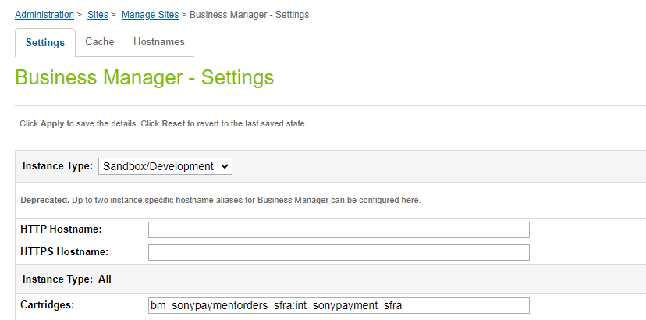

Go to BM > Administration > Organization > Roles > Administrator - Business Manager Modules

Enable BM Module to manage Order authorized by Sony Payment

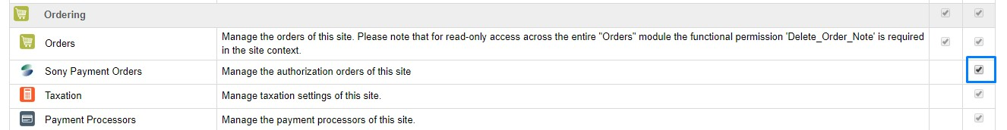

### Import metadata

* Go to BM -> Administration -> Site Development -> Site Import & Export

NOTE: Change the site name in the zip file.

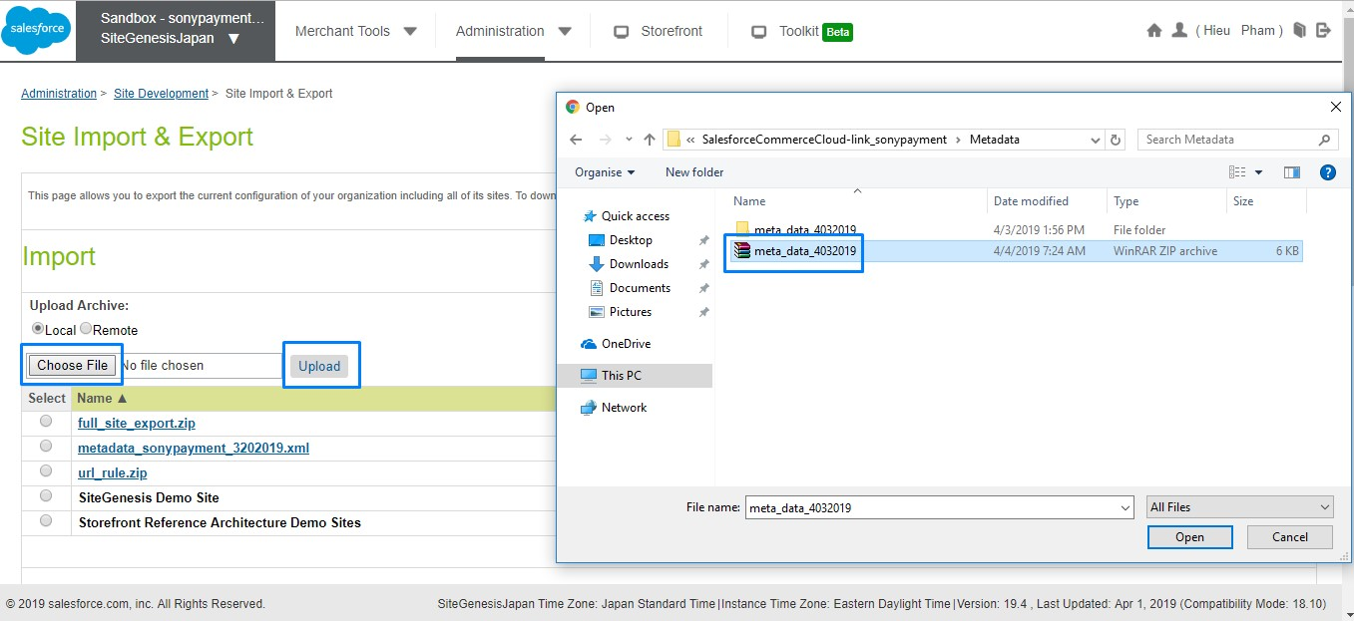

* Click to Choose File -> Choose meta_data_21052019.zip -> click button upload
* After finish upload file, choose uploaded file and click import button

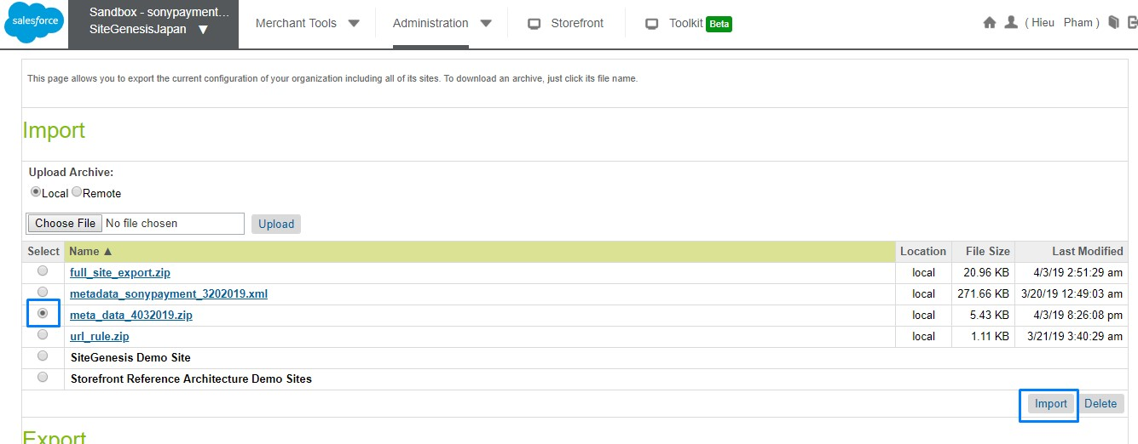

* Click OK to confirm the import process.

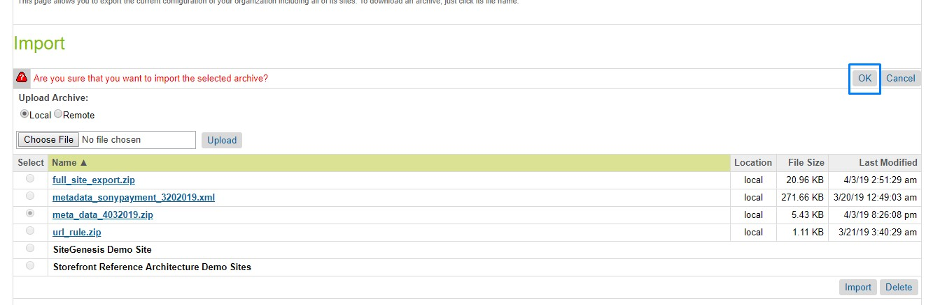

### Import production service

Only when you import production services on Staging. Choose file link_sonypayment\metadata\services_production.xml

Go to Business Manager -> Administration -> Operations -> Import & Export --> Click to upload a file -> Choose services_production.xml -> click button upload

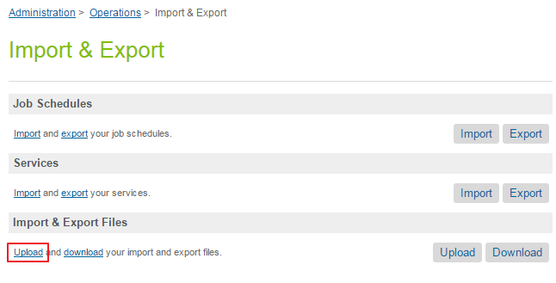

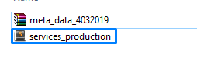

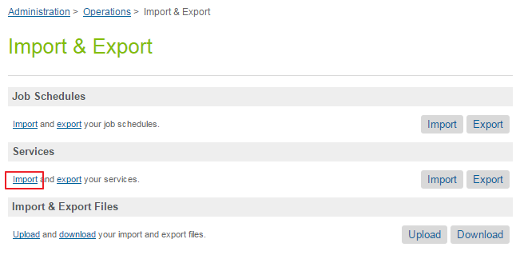Click import -> choose services_production.xml -> next

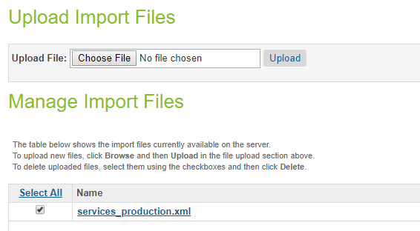

Go to Business Manager --> Administration --> Operations --> Services to check

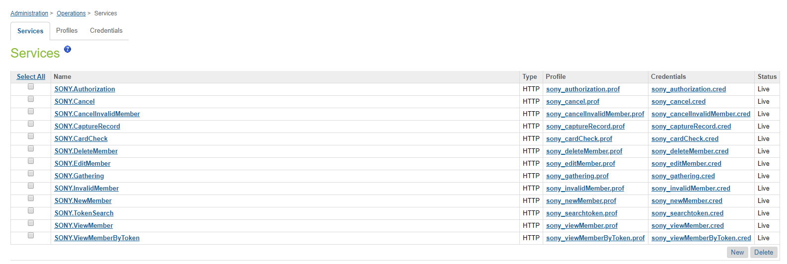

Please note for all services for testing environment, the domain should be: test.e-scott.jp

For production environment, domain should be : e-scott.jp

### Custom Preferences

* Go to Business Manager -> Choose your site -> Merchant Tools > Site Preferences > Custom Site Preference Groups > Sony Payment Configurations

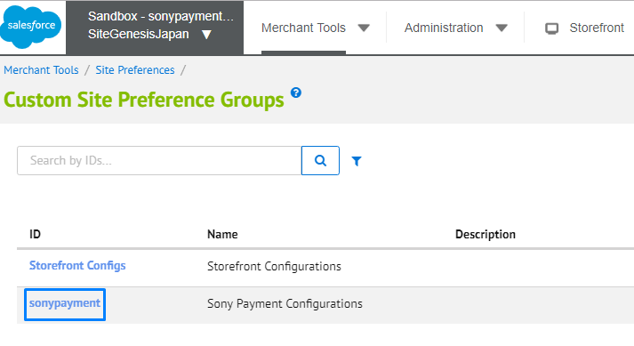

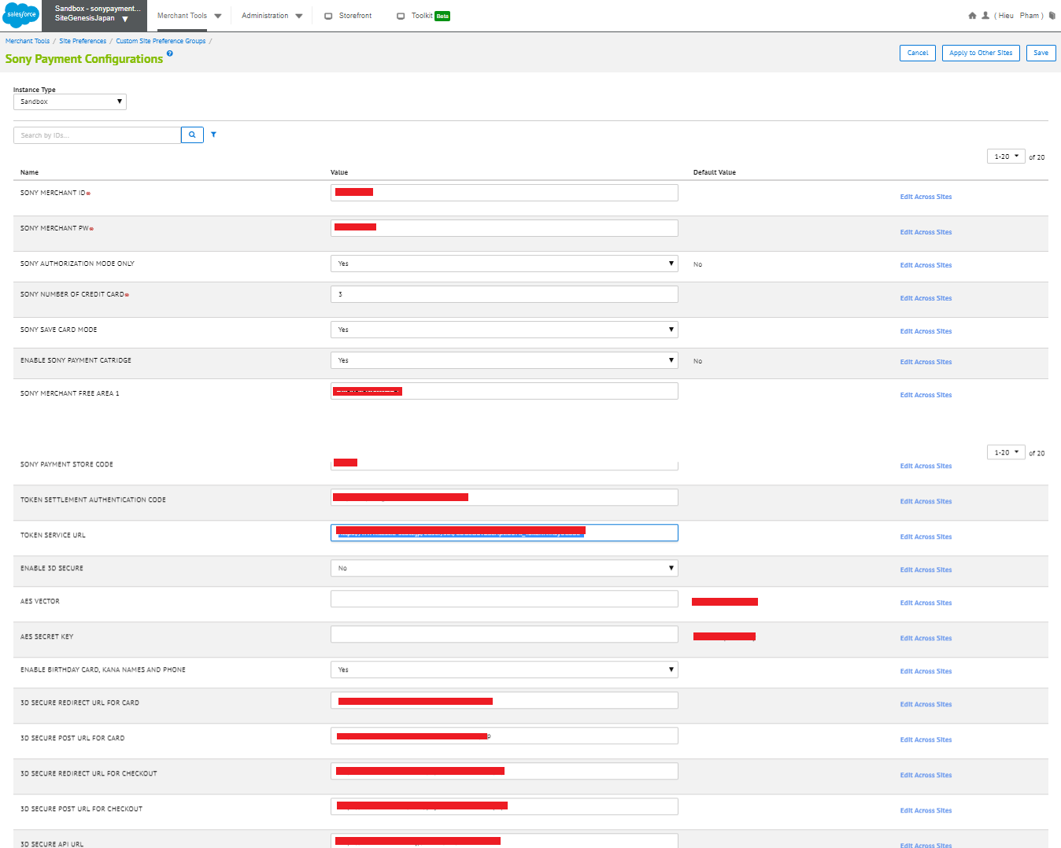

* SONY MERCHANT ID
  + Set the merchant ID that is specified from the Sony Payment.
* SONY MERCHANT PW
  + Set the merchant password that is specified from the Sony Payment.
* SONY AUTHORIZATION MODE ONLY (Yes)
  + If you do not check Credit Card settlement is recorded sales at the same time as the authorization.
  + If you check Credit Card settlement it will be carried out only authorization.
* Sony Number of Credit Cards
  + The maximum number of cards allowed for member registration
* Sony Save Card Mode (Yes)
  + Check if you want to use the Save function of the credit card.
* ENABLE SONY PAYMENT CARTRIDGE (Yes)
  + If you want to use Sony Payment cartridge.
* SONY MERCHANT Free Area 1
  + If you want to input value for MerchantFree1 parameter in request
* SONY MERCHANT Free Area 2
  + If you want to input value for MerchantFree2 parameter in request.
* SONY PAYMENT Store Code :
  + - The Tenant ID specified from Sony Payment.
* TOKEN SETTLEMENT AUTHENTICATION CODE
  + The authentication code to use token service specified from the Sony Payment.
* TOKEN SERVICE URL : check token service url in 3.1.Setup
* ENABLE 3D SECURE (Yes)
  + Check if want end-user input 3D secure password step.
* AES Vector
  + AES Vector used to encode/decode paramters before send to 3D Secure service
* AES Secret Key
  + AES Secret Key used to encode/decode paramters before send to 3D Secure service
* ENABLE Birthday Card, Kana Names and Phone (Yes)
  + Check if want to show birthday, kana names and phone in credit card form.
* 3D Secure Redirect URL for Card
  + The Redirect URL from SFCC to retrieve result after 3D Secure Card management process.
* 3D Secure Post URL for Card
  + The Post URL from SFCC to retrieve result after 3D Secure Card management process.
* 3D Secure Redirect URL for Checkout
  + The Redirect URL from SFCC to retrieve result after 3D Secure Checkout process
* 3D Secure POST URL for Checkout
  + The POST URL from SFCC to retrieve result after 3D Secure Checkout process
* 3D Secure API URL
  + Check 3.1.Setup

### Configuration Enforce HTTPS

Go to Business Manager -> Administration -> Global Preferences -> Security -> Access Restriction. Config information like below:

* Make sure Enable Enforce HTTPS on your sandbox (If not, you will have some issue with session when use 3dsecure redirect)

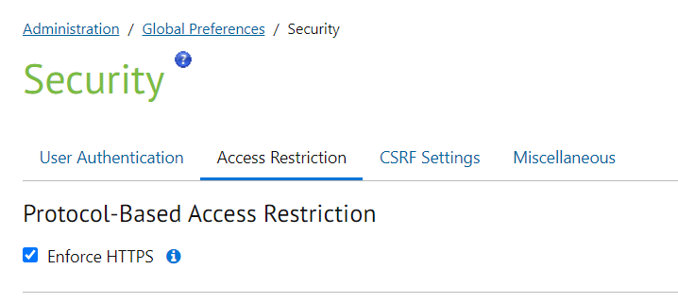

### Configuration custom log

Go to Business Manager -> Administration -> Operation -> Custom Log Settings. Config information like below:

**Step 1:** Add new **SONY** log category with log level is DEBUG --> Click Add button

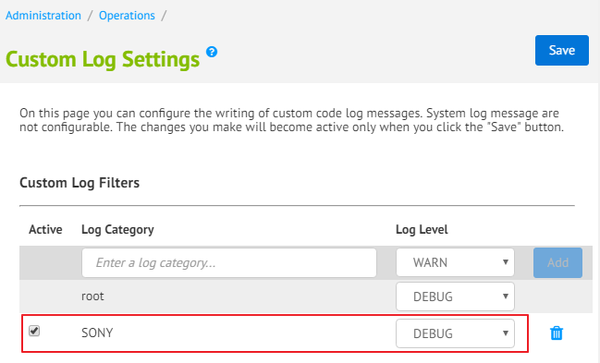

**Step 2:** Add your email to received messages with log level FATAL --> Click Add button

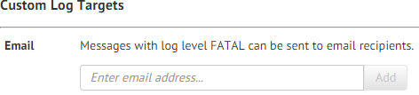

**Step 4**: Select all log level.

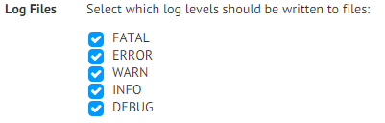

**Step 5**: Click Save button in the top to save all info.

Review the custom log file in Business Manager by clicking **Administration** --> **Site Development** --> **Development Setup --> Log File --> Login by your sandbox account**

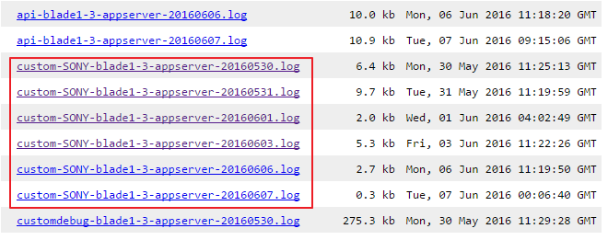

## Custom Code

With SFRA code, we can implement Sony Payment as the plugin in the custom cartridge. Copy the cartridge int_sonypayment_sfra into the folder cartridges in custom cartridge:

* Core cartridge and custom cartridge:

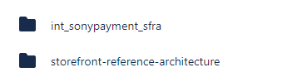

* 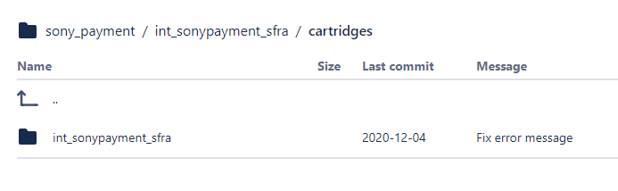Cartridge int_sonypayment_sfra in custom cartridge of project

With SFRA BM code, copy the cartridge bm_sonypaymentorders_sfra into core cartridge:

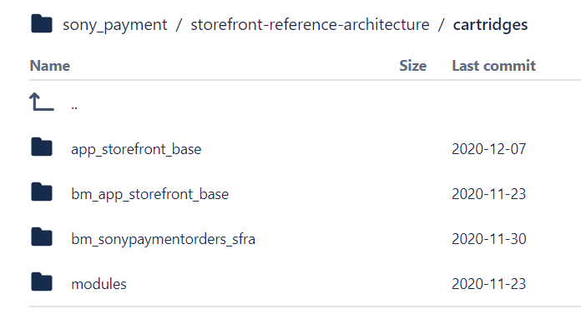

## External Interfaces

Not Require

## Firewall Requirements

Not Require

## Failover

This is a separate cartridge, so you can remove or update this cartridge if you have any issues in your project.

In case the service is down, please contact Sony Payment administrator for more information about the service.

## Testing

Please see file for use case scenarios:

link_sonypayment\documentation\TestCases\SonyPayment_SFRA_20201216.xlxs

# Operations, Maintenance

## Data Storage

N/A

## Availability

N/A

## Support

For cartridge support, please contact Isobar Commerce Support (IsobarCommerceAPAC@Isobar.com).

For Sony Payment API support, please contact your Sony Payment Integrator representative.

# User Guide

## Roles, Responsibilities

N/A

## Business Manager

### Sony Order Management in BM

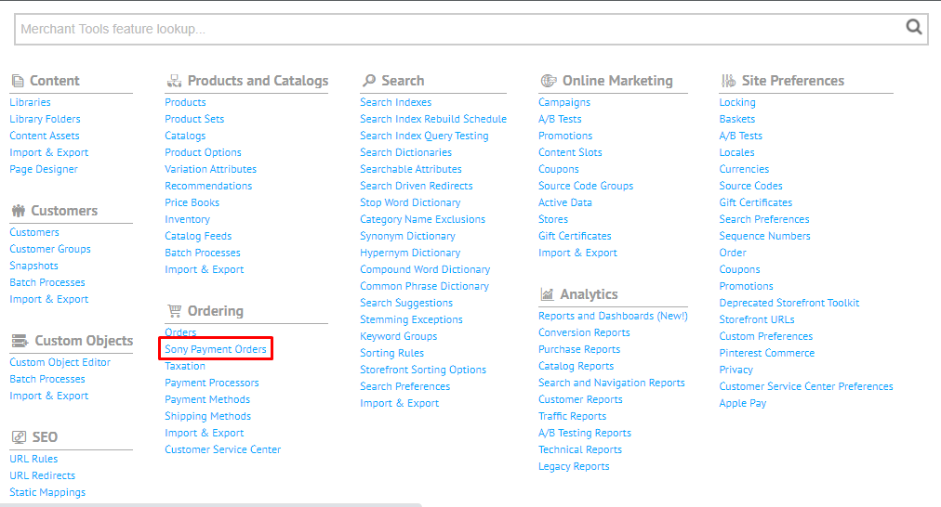After done 3.3.1, you will able to see BM extension page from this link ‘Sony Payment Orders’

This page only showed Order Authorized and not captured yet.

You can find order by inputing order number

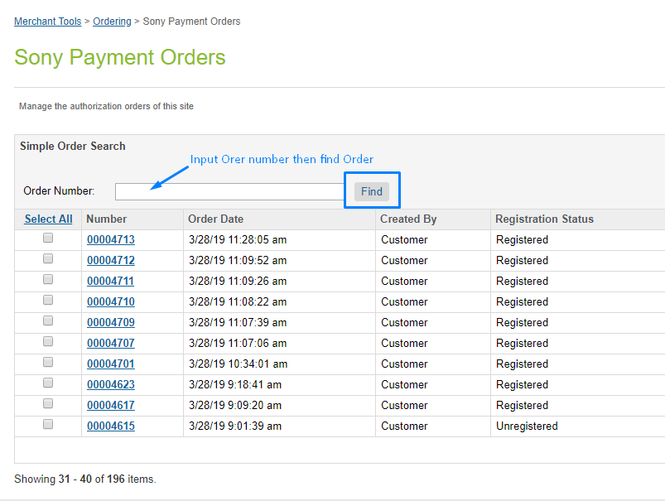

You can select order or some orders to capture/cancel them

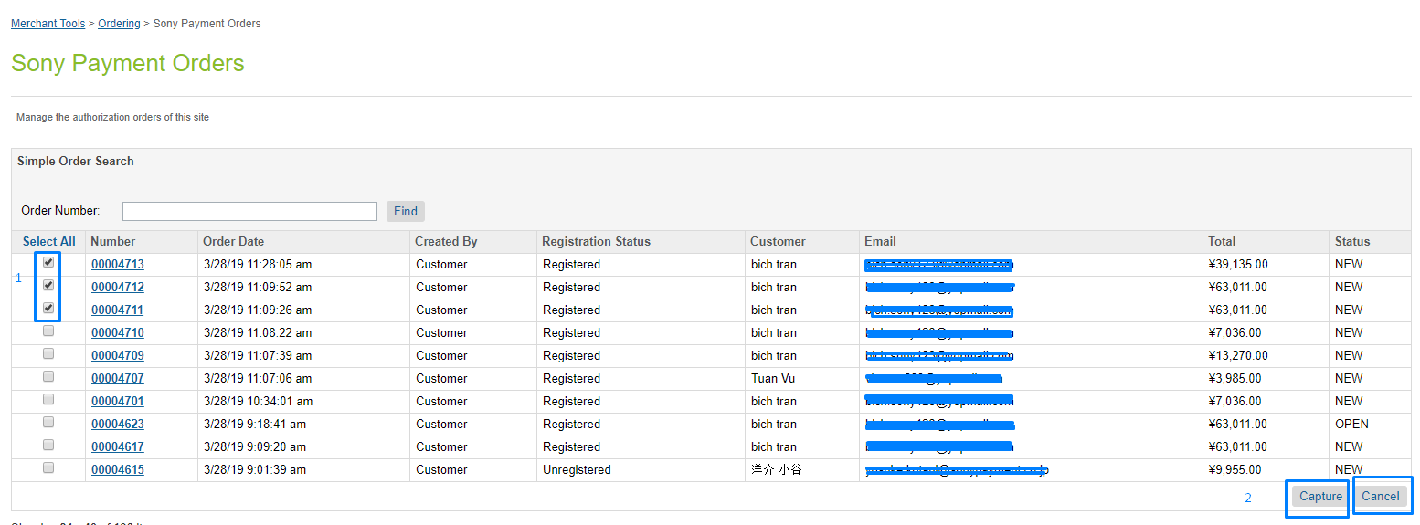

Once click on Capture or Cancel button, there will be message if success or failed on top of page

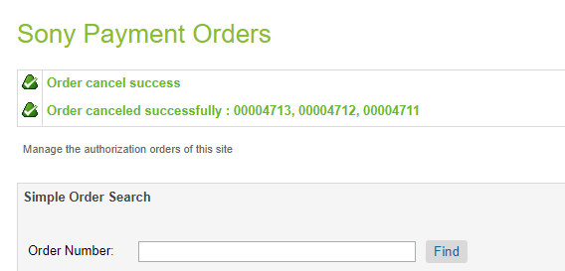

## Storefront Functionality

*N/A*

## Sony Merchant Dashboard user guide

Please check file link_sonypayment\documentation\USER'S GUIDE_SONY PAYMENT MERCHANT.doc

# Known Issues

*N/A*

# Release History

|  |  |  |
| --- | --- | --- |
| **Version** | **Date** | **Changes** |
| 20.0.0 | 2020/Dec/16 | Initial release for SFRA |
|  |  |  |
|  |  |  |
|  |  |  |
|  |  |  |
|  |  |  |
|  |  |  |
|  |  |  |